*<This document is a template for evaluators to use when drafting evaluation reports for USDA-funded International Food Assistance Projects. The purpose of this document is to improve the accessibility and quality of evaluation reports. Evaluators should follow the formatting of this document (e.g. heading styles, tables of content), as it complies with most Section 508 requirements. While evaluators are encouraged to review and comply with the content suggestions, USDA understands that project’s unique circumstances may require deviation from what is outlined here.*

*For more information on how to make documents accessible, please visit* [*section508.gov*](http://www.section508.gov)*.*

*Before submitting your report,* ***please remove all italicized text and comments****.>*



INSERT PHOTO HERE

[COUNTRY] [Program] Project

[Evaluation Type]

[Date Published]

[Title of Evaluation Report]

Program: McGovern-Dole International Food for Education and Child Nutrition

Agreement Number: [XXX]

Funding Year: Fiscal Year 20[XX]

Project Duration: [AGREEMENT PERIOD]

Implemented by: [PVO]

Evaluation Authored by: [EVALUATION FIRM]

[NAME OF EVALUATION TEAM LEADER(S) WHO

WILL BE LISTED AS REPORT AUTHORS WHEN PUBLISHED]

*<All reports should have a table of contents to help readers quickly navigate the document. The table should be created using Word’s Table of Content’s feature under the “References” tab. This will ensure that page numbers are automatically updated and help make the document is accessible when converted into a pdf.*

*Note that for the table function to work, and for the document to be accessible, you must use proper heading styles. To do this, go to the “Home” tab in Word. In the “Styles” section of the ribbon, you should select “Heading 1” for section headings, “Heading 2” for subheadings, Heading 3 for sub-sub headings, etc. This document is already structured using proper headings and can be used as an example.>*

Table of Contents

List of Acronyms 6

Executive Summary (Not to exceed 4 pages) 7

Project Background and Purpose 7

Findings and Conclusions 7

Recommendations 7

1. Introduction and Purpose 8

1.1. Project Context 8

1.2. Project Description 8

1.3. Results Framework 8

1.4. Purpose of the Evaluation 8

2. Evaluation Design and Methodology 9

2.1. Evaluation Questions 9

2.2. Evaluation Design 9

2.3. Sampling methods 9

2.4. Data Collection Methods 10

2.5. Data Analysis Methods 10

2.6. Evaluation Limitations 10

3. Findings 11

4. Conclusions 12

5. Recommendations 13

Annexes 14

Annex 1: Figure Formatting 15

Annex 2: Table Formatting 16

*<Adding a separate list of figures and list of tables is optional, though encouraged. As with the table of contents, this table will auto populate if you use proper captioning via the Ribbon and picture formatting. This is explained later in the document.>*

List of Figures

Figure 1: Example of Correctly Formatted Picture 15

Figure 2: Accessible Graph Example 15

List of Tables

Table 1: Accessible Example – School Attendance 16

Table 2: Inaccessible Example – School Attendance 16

# List of Acronyms

|  |  |
| --- | --- |
| Acronym | Full Term |
| DEC | Development Experience Clearinghouse |
| FFPr | Food for Progress |
| FY | Fiscal Year |
| SOW | Statement of Work |
| USDA | U.S. Department of Agriculture |

# Executive Summary (Not to exceed 4 pages)

*<The Executive Summary should summarize the key sections of the full report without adding new information. The Executive Summary should ideally be no more than three to four pages.>*

## Project Background and Purpose

*<Briefly describe the project and its activities, along with any other contextual information that is important to understanding the project. Then describe the overarching purpose of the evaluation and how the findings are expected to be used to inform decisions.>*

## Evaluation Questions, Design, Methods and Limitations

*<This section lists the Evaluation Questions and describes the overall design, specific data collection and analysis methods linked to the evaluation questions, and limitations of the data, methods, or other issues that affected the findings.>*

## Findings and Conclusions

*<This section should report those findings based on evidence generated by the evaluation data collection and analysis methods. Findings should be fact-based and not rely only on opinion, even of experts. Conclusions are drawn directly from findings and help summarize the “so what” of the findings. Several findings can lead to one or more conclusions. Whenever possible, data should be presented visually in easy to read charts, tables, graphs, and maps to demonstrate the evidence that supports conclusions and recommendations.>*

## Recommendations

*<This section should clearly list the evaluator’s recommendations for the project. For the Executive summary, a few sentences per recommendation is sufficient. More detail will be provided in the full Recommendations section later. >*

# Introduction and Purpose

## Project Context

*<This section should briefly describe the context in the country or region that the project is being implemented. This should include any social, political, demographic, institutional, or gender equality factors that are relevant to this project. Ultimately, this section should give the reader a basic understanding of the problem that the project is intended to solve and obstacles in the way of solving the problem(s).>*

## Project Description

*<This section should describe the project and include:*

* *Project activities and implementation strategy.*
* *Location(s) of project activities.*
* *Target Population.*
* *Stakeholder roles and contributions to the project.*
* *Project status (e.g. year one of a four-year project, year four of a four-year project, etc.).*
* *Project budget.>*

## Results Framework

*<Include the following information in the Results Framework section:*

* *Project’s theory of change*
* *Results Framework graphic (could also be put in an annex)*
* *Critical assumptions>*

## Purpose of the Evaluation

*<The section describing the purpose of the evaluation should include:*

* *The type of evaluation (baseline, midterm, final, special, etc.).*
* *The basic purpose of the evaluation (e.g. establishing a baseline, measuring impact of an intervention, etc.).*
* *Any previous evaluations related to the project.*
* *The intended audience of the evaluation.*
* *How the evaluation findings will be used by the PVO/implementor.*
* *How the evaluation informs the program’s broader Learning Agenda (linked below).*
  + [*McGovern-Dole Learning Agenda*](https://www.fas.usda.gov/sites/default/files/2020-03/mgd_learning_agenda_final.pdf)
  + [*Food for Progress Learning Agenda*](https://www.fas.usda.gov/sites/default/files/2020-03/learning_agenda_final.pdf#:~:text=Food%20for%20Progress%20Learning%20Agenda%20on%20Trade%20Expansion,timely%20research%20questions%20to%20inform%20evaluation%20and%20policy)*>*

# Evaluation Design and Methodology

## Evaluation Questions

*<List the evaluation questions in the context of relevance, effectiveness, efficiency, impact, and sustainability (note, these should have been outlined in the Statement of Work/Terms of Reference). Explain how these questions algin with the project’s strategic objectives and results.*

*[Within these five categories, there should be evaluation questions that investigate if the interventions contributed to equity for marginalized populations, particularly women and girls. There should also be questions that explore potential unintended consequences of the project.>*

## Evaluation Design

*<This section of the report should give a description of the overall design/approach used for this evaluation. The reader should get a sense of what the evaluators did and why, without getting into the detailed calculations that will be discussed in the next section. Items that should be included are:*

* *The type of evaluation e.g. impact evaluation (experimental or quasi-experimental design), non-experimental performance evaluation, needs assessment etc.).*
* *How culturally appropriate participatory methods were incorporated into the design.*
* *How ethical standards regarding all participants, especially at-risk populations, were incorporated into the evaluation design.>*

## Sampling methods

*<This section describes the basic sampling strategy that was used during the evaluation. It should give the reader the information necessary to judge the validity of the samples. Information that should be included either here or in an annex include:*

* *The sampling frame*
* *Rationale and mechanics of participant selection for sample*
* *Number of participants selected out of potential subjects*
* *If the evaluation utilizes counterfactual/control groups, describe the selection criteria for those groups. There should be enough detail for a reader to determine whether the groups provide a valid comparison.*
* *Limitations of the sample*
* *Minimum detectable effect*
* *Confidence level>*

## Data Collection Methods

*<This section describes the data collection methods and instruments (both qualitative and quantitative) and analysis tools that were used in the evaluation. The actual instruments themselves (e.g. full surveys and interview guides) should be included in the annexes. Items that should be discussed here are:*

* *Level of precision required (quantitative methods)*
* *Value scales or coding used (qualitative analysis)*
* *Level of participation*
* *Description of how collections tools were developed/adapted to be relevant to local stakeholders and culturally appropriate*
* *Empowerment of stakeholders through the evaluation process*
* *Reliability of the data*
* *How the data collection methods were design to collect gender related data, including adequate sex disaggregated data and questions reflecting gender issues.>*

## Data Analysis Methods

*<While the other sections described how the data was collected, this section describes how those data are analyzed. Common methods of analysis include regressions, difference-in-difference calculations, interview coding, etc. It should be clear how these methods are linked to each of the evaluation questions and why they are appropriate to answer those questions.>*

## Evaluation Limitations

*<Outline key limitations of the evaluation (for example: lack of baseline data; selection bias as to sites, interviewees, comparison groups; seasonal unavailability of key informants; contamination of control groups, etc.) and how these were mitigated.>*

# Findings

*<Findings are empirical facts based on data collected during the evaluation and should not rely only on opinion, even of experts. It should report both qualitative and quantitative data, and also report on the project’s key performance indicators (a table with the results of all performance indicators should be included in an annex).*

*The findings should also consider the possibility of unintended side effects of the intervention. This could include an analysis of how project interventions affected various segments of the population differently (e.g. different affects based on sex, gender, socio-economic status, age, etc.).*

*Impact evaluations that aim to identify causal attribution should report the results of statistical analysis in the findings section or an annex. Depending on the type of impact evaluation design and model approach, the information that accompanies the results can vary. However, it is standard practice in the field to report a few key elements of statistical results. This includes:*

1. *Coefficients and standard errors for the dependent and independent variables.*
2. *R2 - coefficient of determination.*
3. *Root Mean Squared Error.*
4. *Statistical significance of equation (F-test) and estimates (t-test) or corresponding p-values.*
5. *A description or interpretation of the results.>*

# Conclusions

*<Describe the conclusions of the evaluation. Clearly explain how the logic behind the conclusions correlate with actual findings. Conclusions should be substantiated by findings consistent with data collected and methodology used and ultimately answer the Evaluation Questions. If conclusions are tentative, clearly identify the details of what is known and what can be plausibly assumed. Ensure the conclusions add value to the findings. Do not highlight simple conclusions that are already well known and obvious.>*

# Recommendations

*<Recommendations should be relevant to the project, Terms of Reference (TOR), and objectives of the evaluation and formulated clearly and concisely. Describe how the evidence and analysis provide the basis for the recommendations. Recommendations must be specific and actionable, prioritized to the extent possible, and include responsibilities and a timeframe for their implementation. They should also take into account gender and other intersectional issues, as relevant.>*

# Annexes

*<All relevant annexes should be part of the report. Annexes that are required for USDA evaluations are:*

* *Bibliography*
* *Table of indicator data (including targets and actuals)*
* *Results Framework (if not included in body of text)*
* *Data collection instruments*
  + *Questionnaires*
  + *Interview guides*
  + *Observation protocols*
  + *Sampling tools*
* *Terms of Reference/Statement of Work for the evaluation*
* *Conflict of Interest form(s)*
* *Key elements of statistical results (required for impact evaluations)*

*Note that USDA requires evaluators to submit a version of the report free from personally identifiable information (PII). Items that should NOT be included in the Annexes (or anywhere in the report) include:*

* *List of participants and/or people interviewed for evaluation.*
* *Names, email addresses, phone numbers, addresses, or similar information linked to individuals*

*For a more detailed description of potential PII, please see FAS’s PII Guidance Document.>*

*<Remember to continue using proper sub-headings in this section to ensure that the table of contents updates correctly. See the non-exhaustive examples below.>*

## Annex 1: Figure Formatting

Figure 1: Example of Correctly Formatted Picture

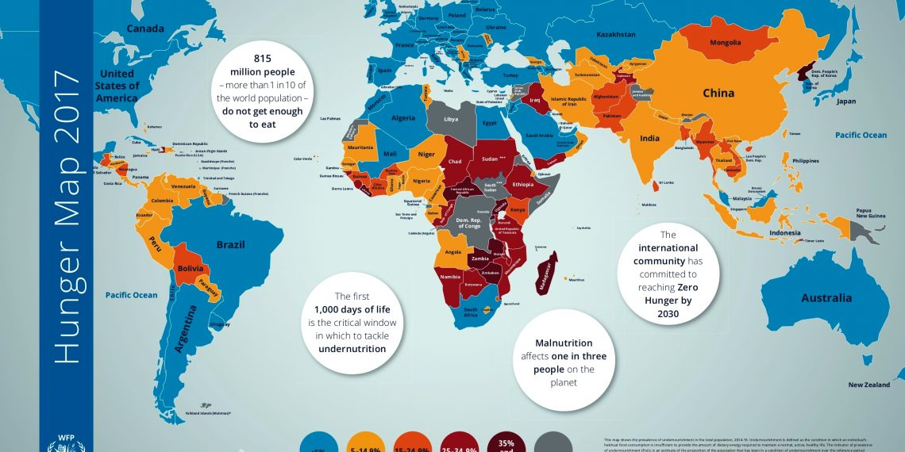

Source: World Food Programme

Figure 2: Accessible Graph Example

## Annex 2: Table Formatting

Table 1: Accessible Example – School Attendance

| **Gender** | **Baseline** | **Midterm** | **Final** |
| --- | --- | --- | --- |
| Boys | 5000 | 6000 | 7000 |
| Girls | 4500 | 6500 | 7000 |

This simple table does not have split or merged cells and has “Repeat Header and Row” selected, making it accessible.

Table 2: Inaccessible Example – School Attendance

|  | Baseline | | Midterm | | Final | |
| --- | --- | --- | --- | --- | --- | --- |
| Boys | Girls | Boys | Girls | Boys | Girls |
| # regularly attend | 4000 | 3500 | 5000 | 6000 | 6500 | 6800 |
| # enrolled | 5000 | 4500 | 6000 | 6500 | 7000 | 7000 |
| % regularly attending | 80% | 78% | 83% | 92% | 93% | 97% |

This table has merged cells and is therefore inaccessible in Word. To remediate, save the table as an image and add alternative text (like with figures) that describes the “bottom line” of what the data is saying.